One Time Run Scripts Executional Steps

OTR Scripts Execution Procedure |  |  | Issued Date :26/05/2021
Version | Date | Description of changes
1.0 | 26/05/2021 | Initial Version
Responsible
Developers:  Infosys Team |  |  |  | Reviewer:  Infosys

Introduction:
- OTR Scripts were introduced as a quick work around for Delta scripts.
- Before executing the OTR scripts we need to pass an input parameter to input file(Mandatory).
- Input File will exist in below location.
- Screenshot is taken from Dev environment

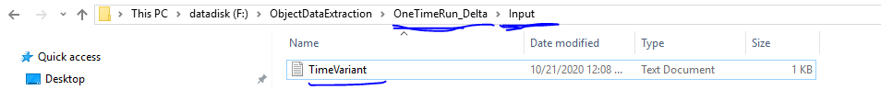

Input must be given in seconds.

Time Calculations:
1 minute = 60 seconds
60 minutes / 1 hour = 3600 seconds
24 hours/ 1 day = 3600*24 = 86400 seconds

Example 1:
If data was not indexed on 20-10-2020, and today is 21-10-2020 then one must run from that date.
OTR Execution date: 21-10-2020.
Input Time: 86400 seconds

Input Time Given:

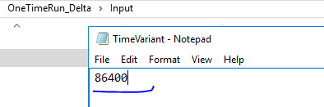
OTR Consideration time: [ “Current Time” – “Input Time” ]

Logic Inside the OTR Scripts
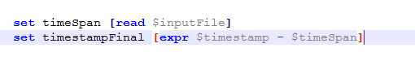
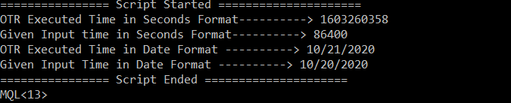

OTR Consideration Time = 20-10-2020
Now the OTR scripts will extract all the modified objects for the OTR consideration Time (20-10-2020)

Example 2:
If I need to run the OTR scripts for 5 days before from the current date, then OTR input time can be given like this 5*86400 =432000

Input changed to 432000, we will get data extracted for last 5 days.
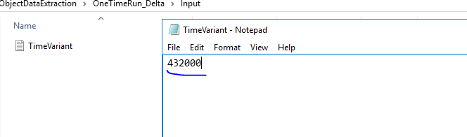

Here the OTR executed time is 10-21-2020 but the given input is 432000 / 5 Days. Now OTR scripts will extract data for the last 5 days i.e 10-16-2020.

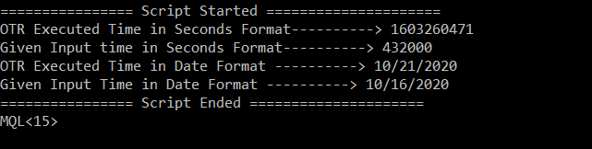

Delta Script Execution:
- Update the all the input file in delta job with the respective downtime:
  - Go to https://www.unixtimestamp.com/index.php path (one day before from patch down day) select date that we need to execute from and click on convert as shown below. We need to modify all input files with latest timestamp. (Server path: /mnt/mql/Delta/Input)
Note: OTR calculation will not work here for delta

  - Ex: 1602806400.

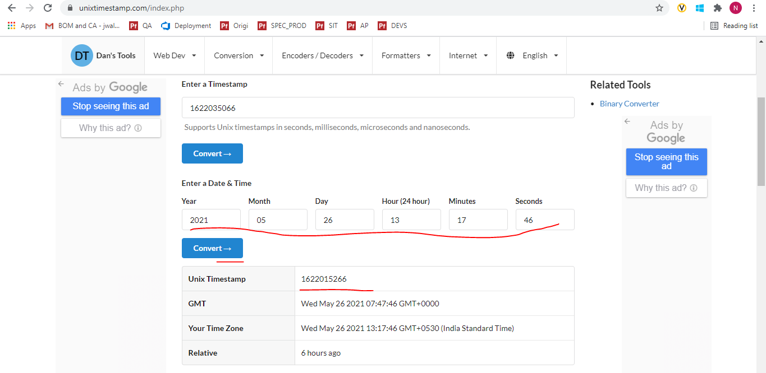

  - Verify if all data has been consumed from Azure portal
  - rclone is running? ps -ef | grep rclone (All rclone mounts should be running)
    - rclone mount enovia-csv-container:enovia-csv-container/ /etc/enovia-csv-content/ --buffer-size 10M --daemon --log-file=rclonelog.txt
    - Delta is running? Check cron logs, verify crontjob status

**End of Document**

